Image :

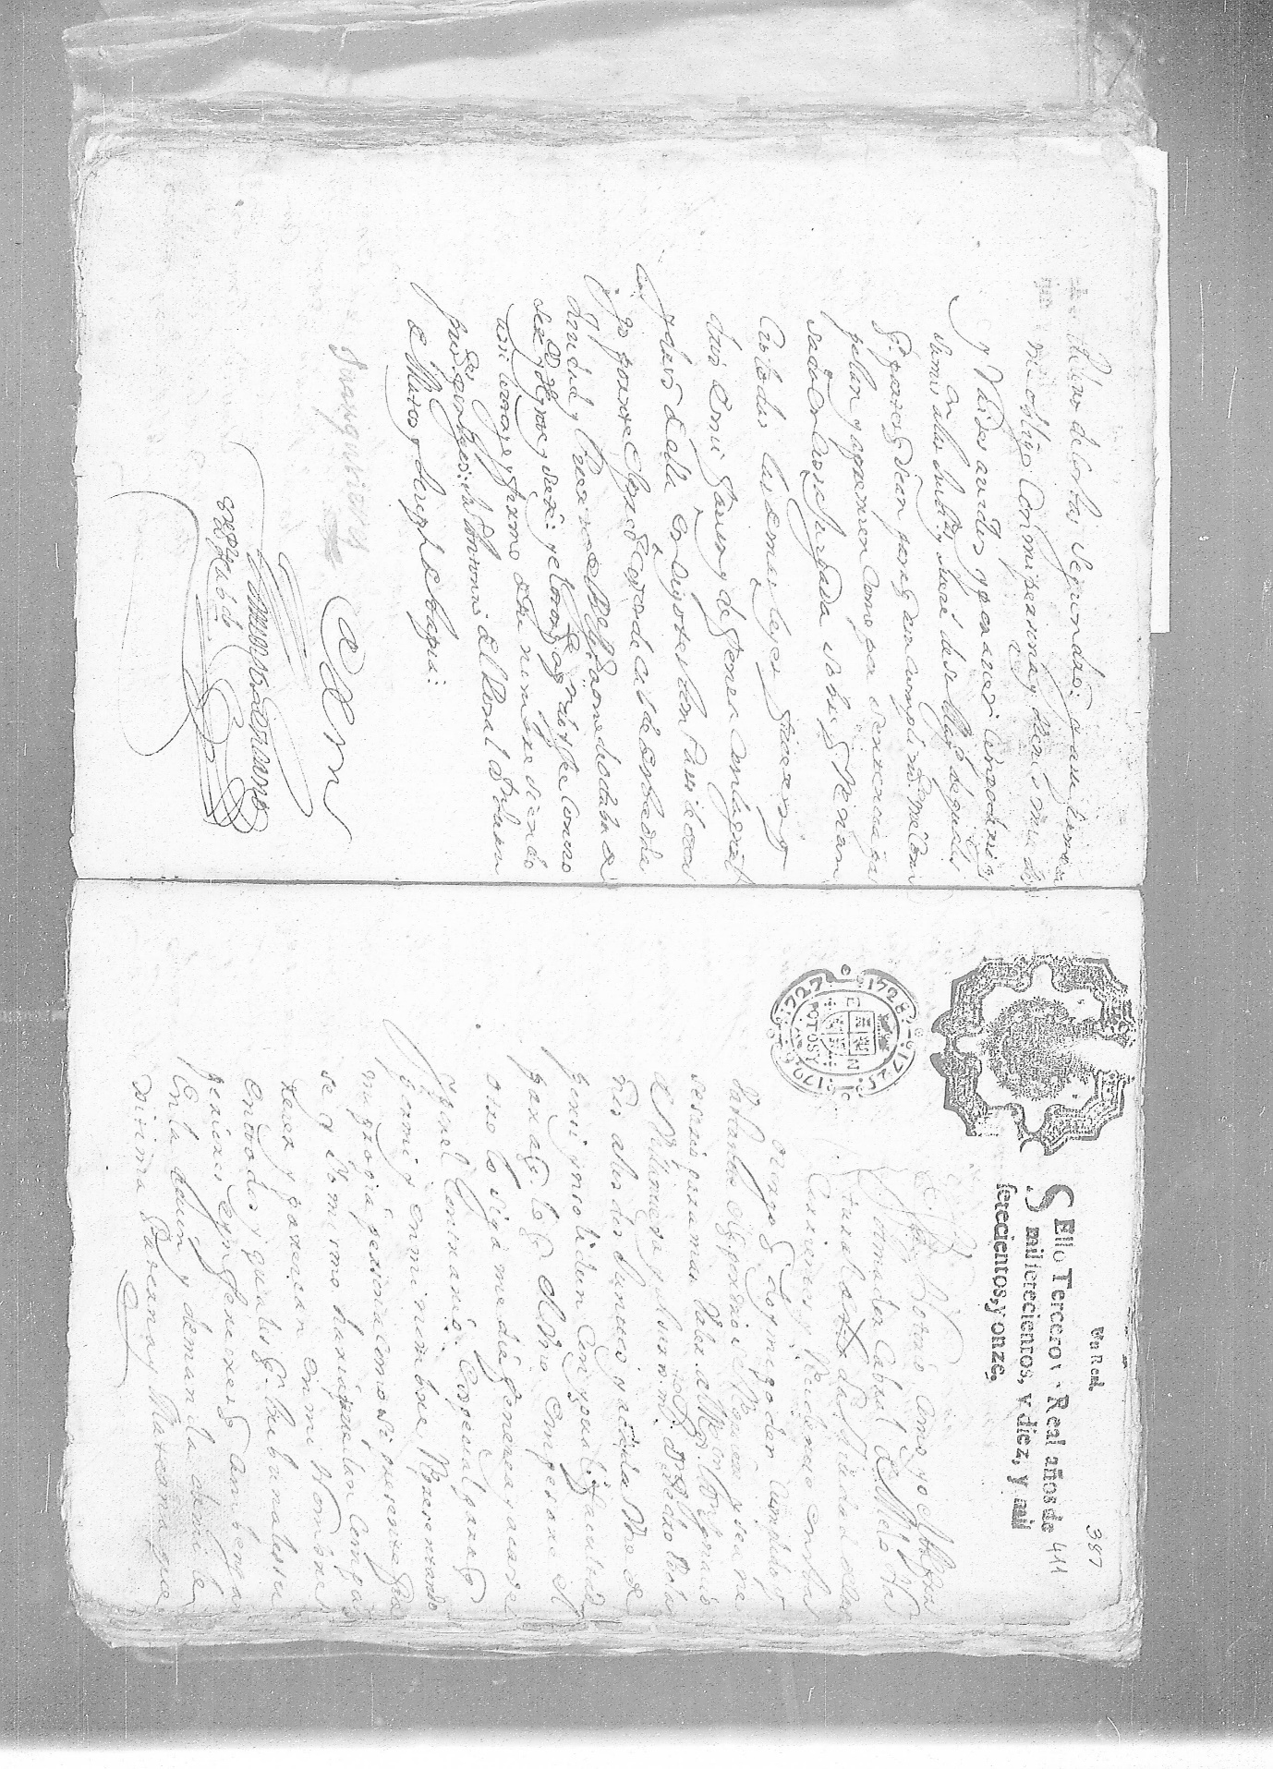

Changing the Threshold value : 200

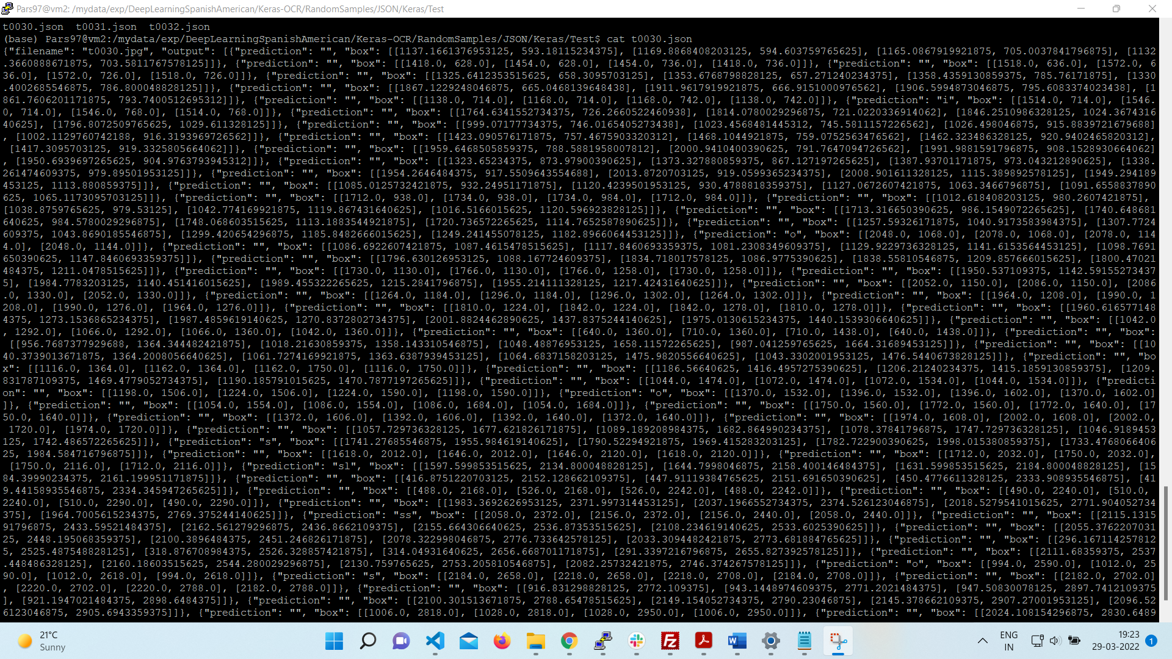

Cleaned Image:

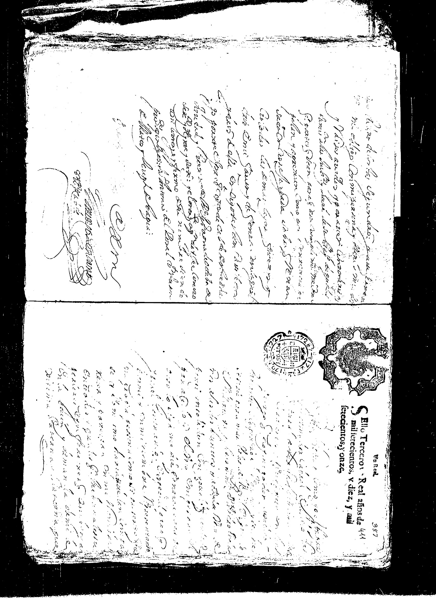

Changing the threshold value to 127:

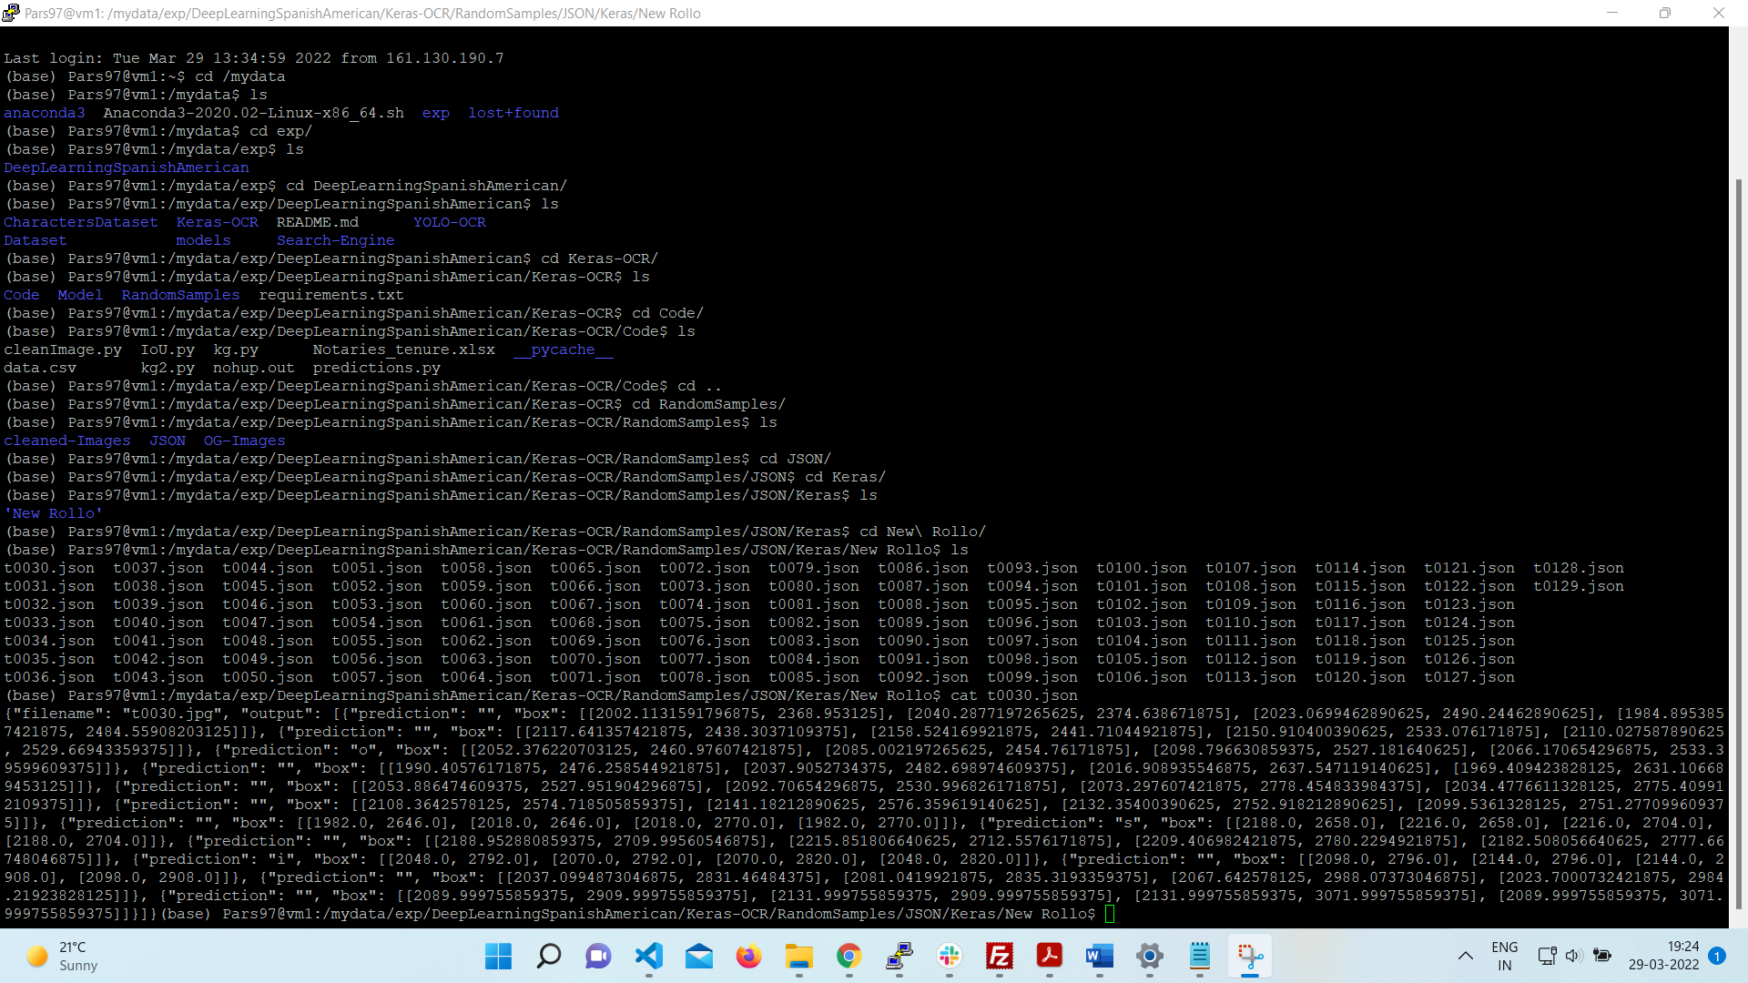

Cleaned image :

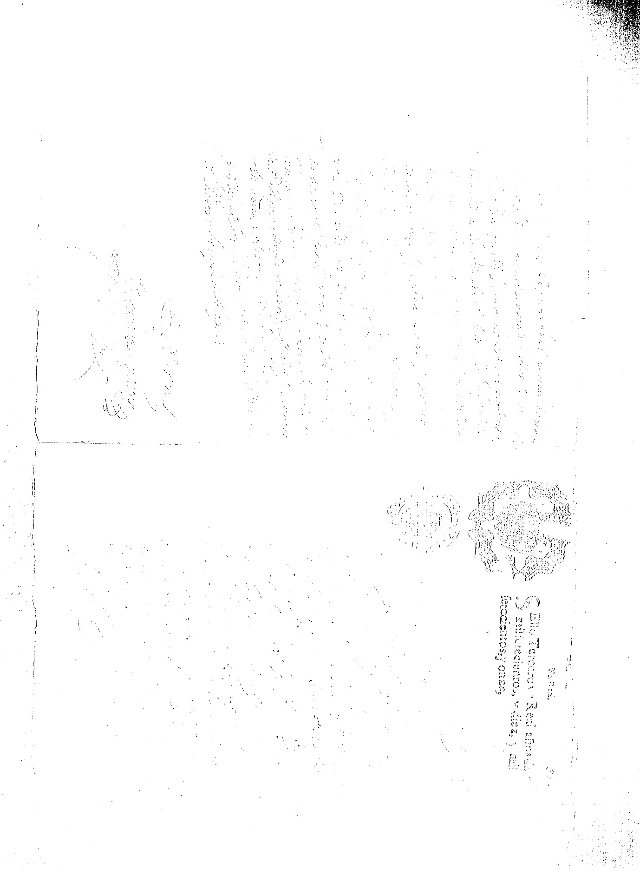

The prediction of the original image:

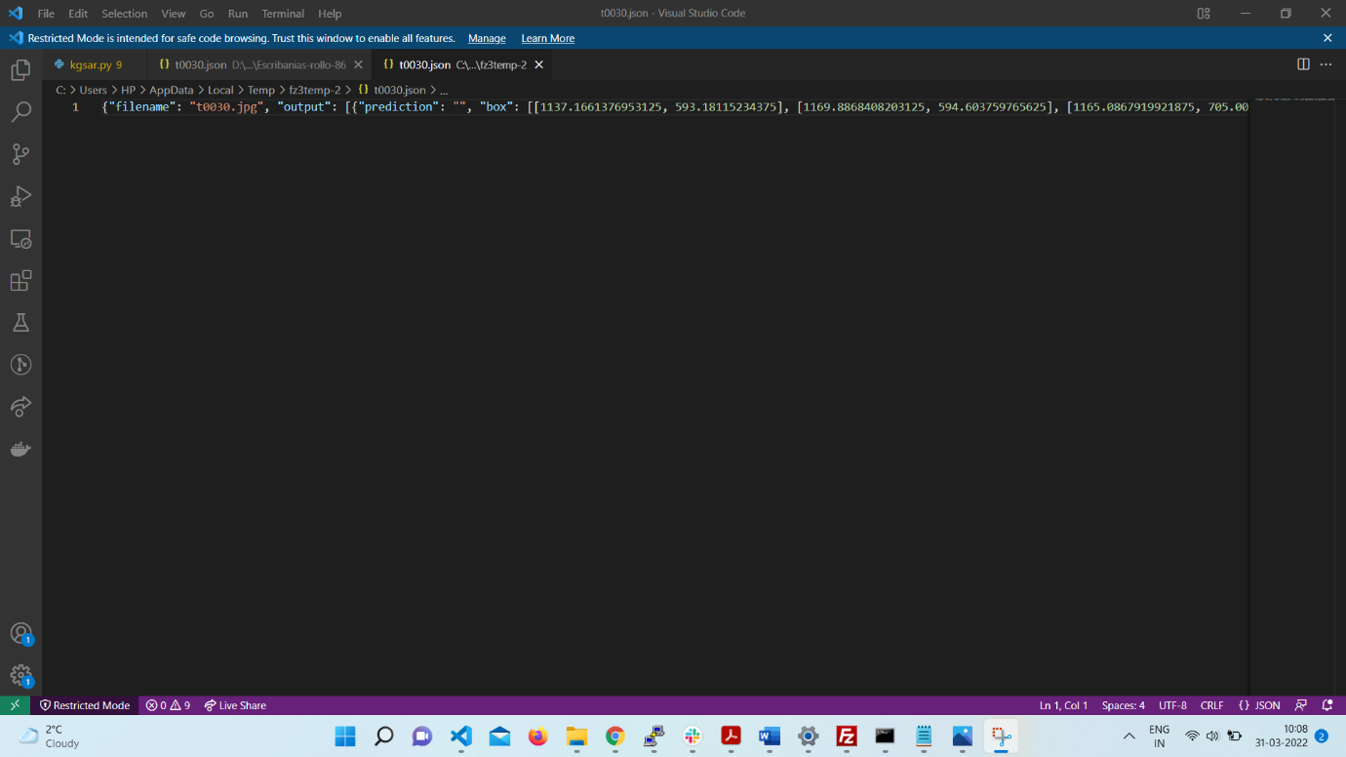

So basically Sir the improvement is working for some of the images in the 30% bracket changing the threshold value is having some significance.

But Sir it is not working for the images like this:

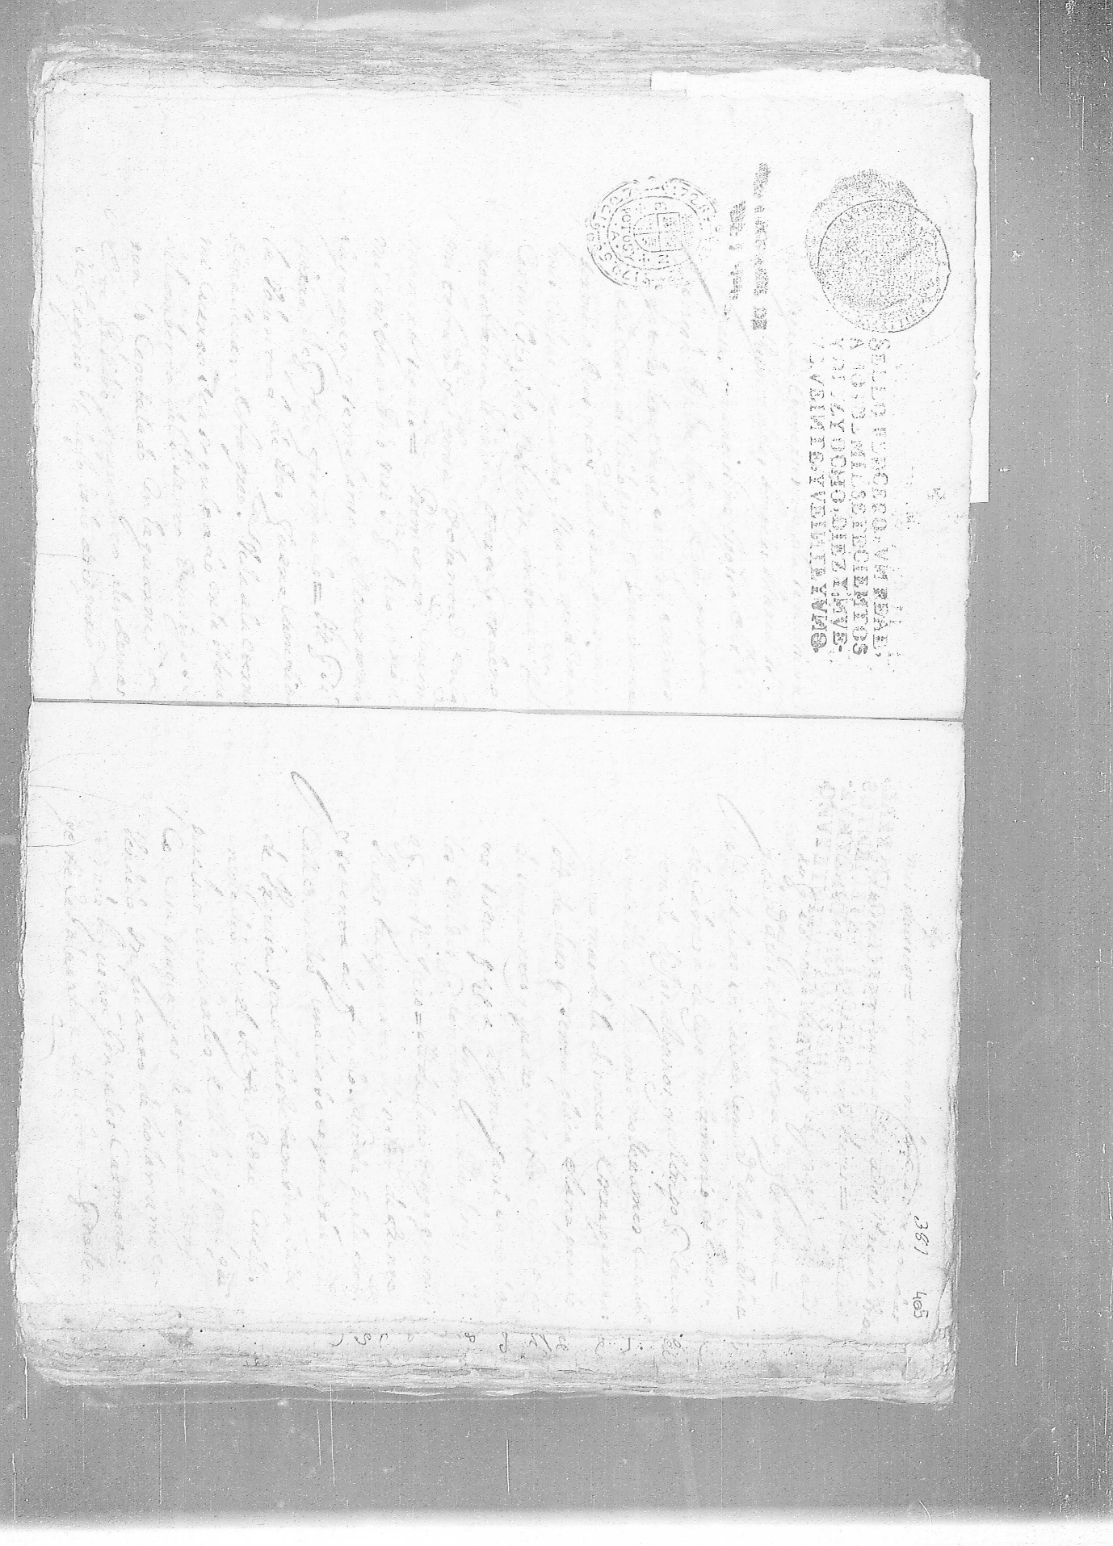

Predictions for image t 0030

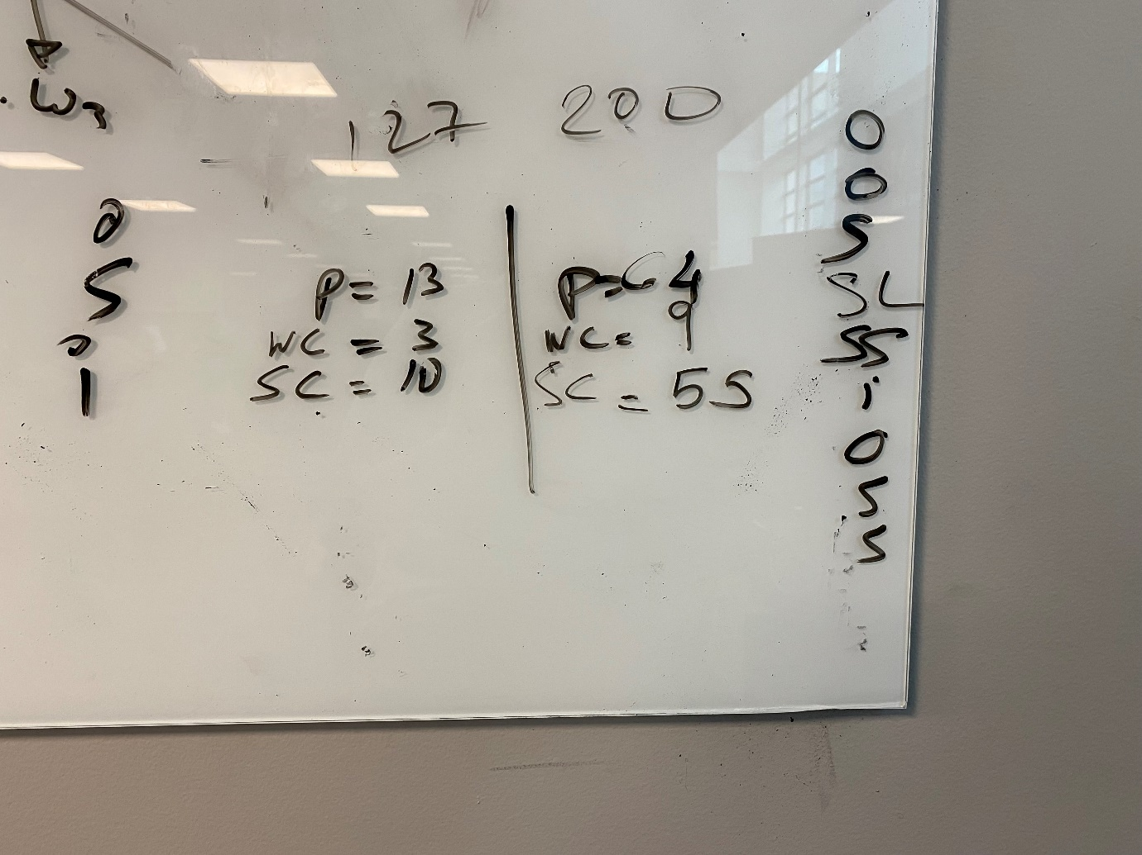

Predictions for image t 0031

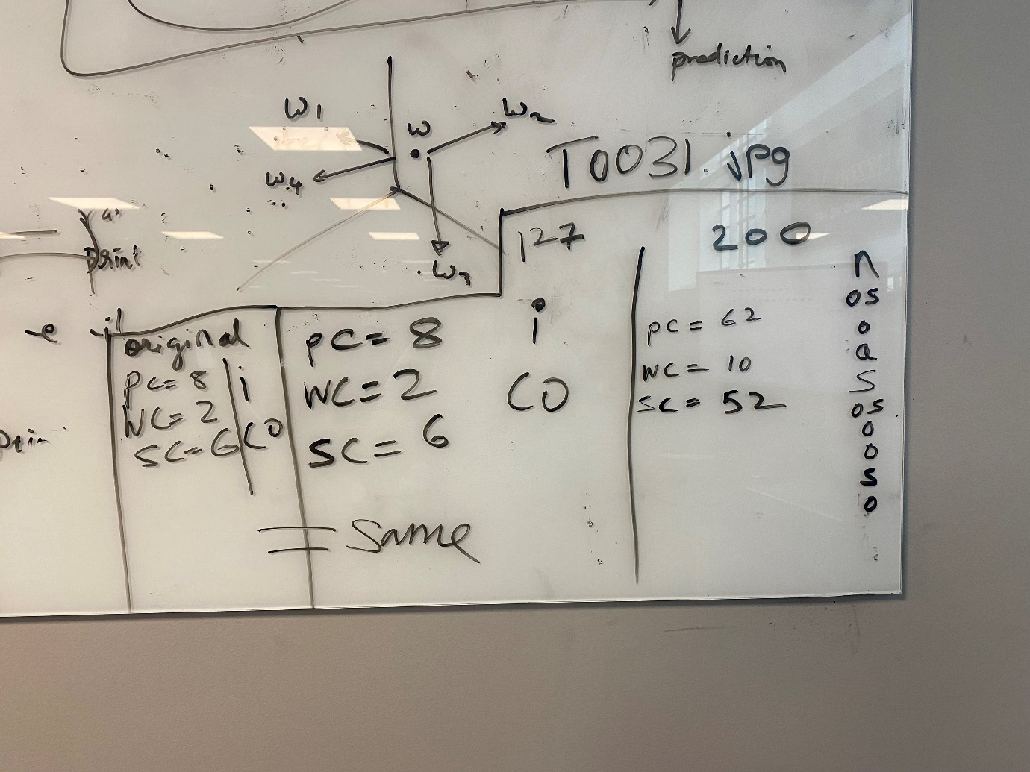

Original Image:

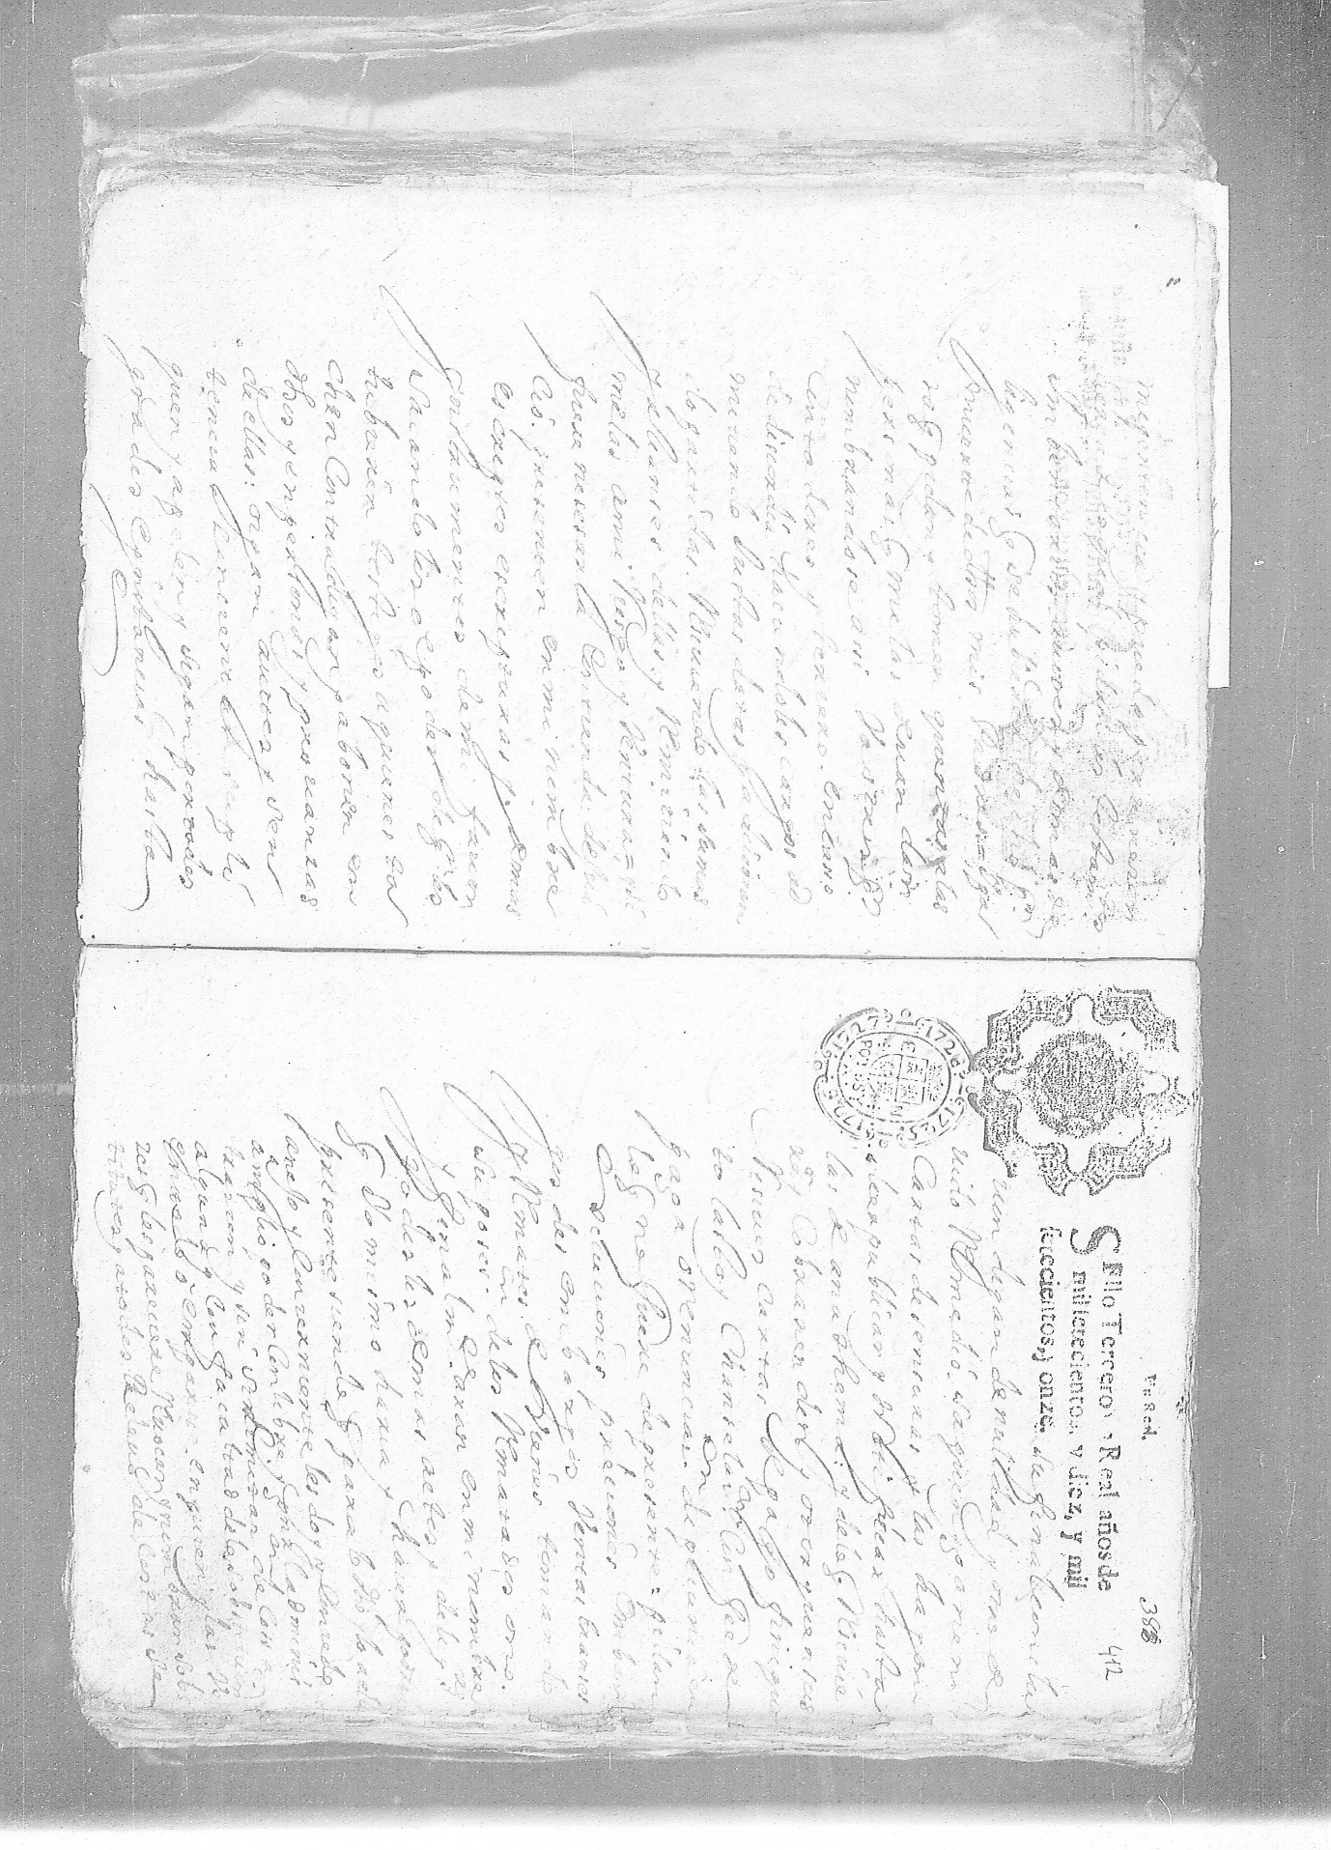

Threshold value: 200

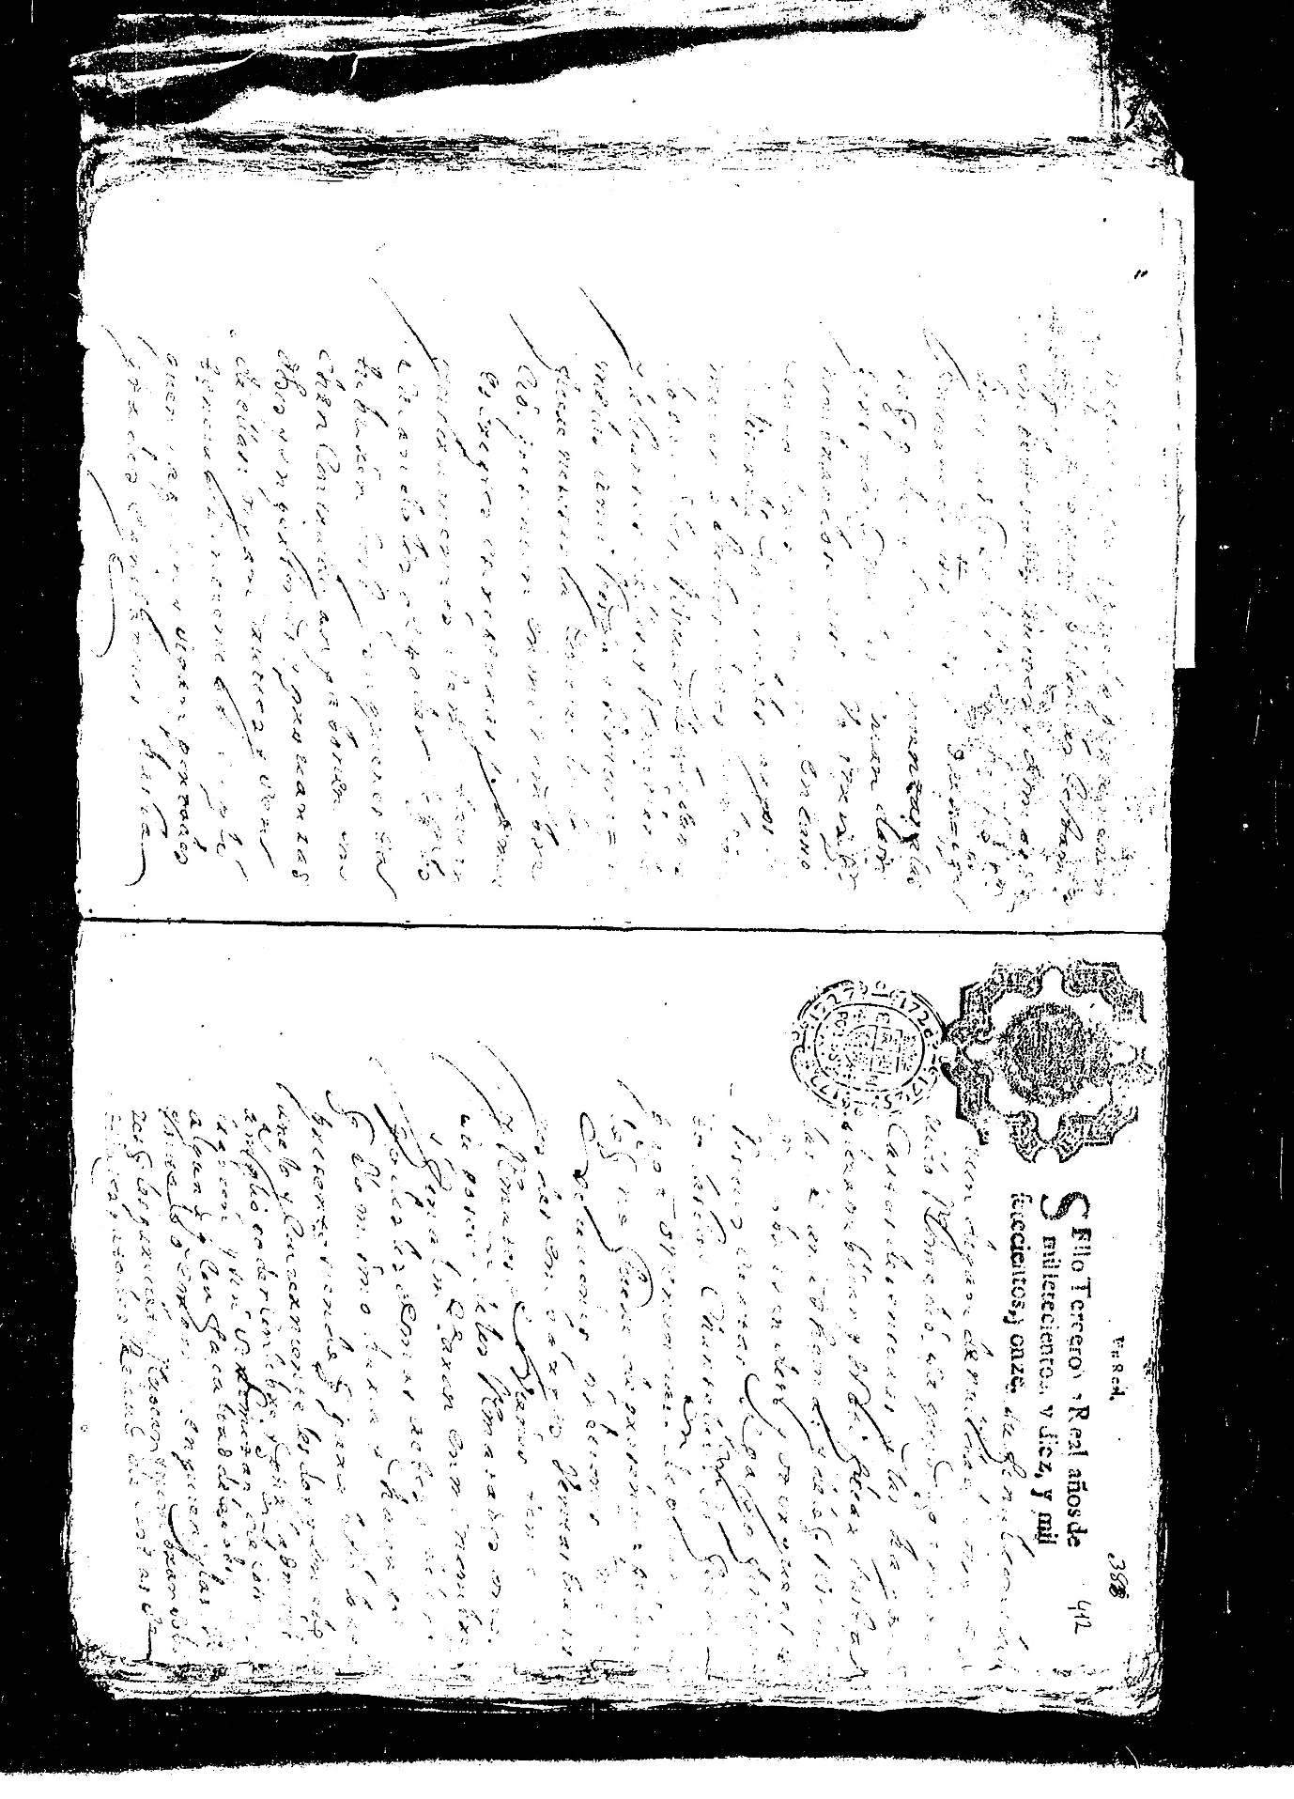

Threshold value: 127



Original Image:

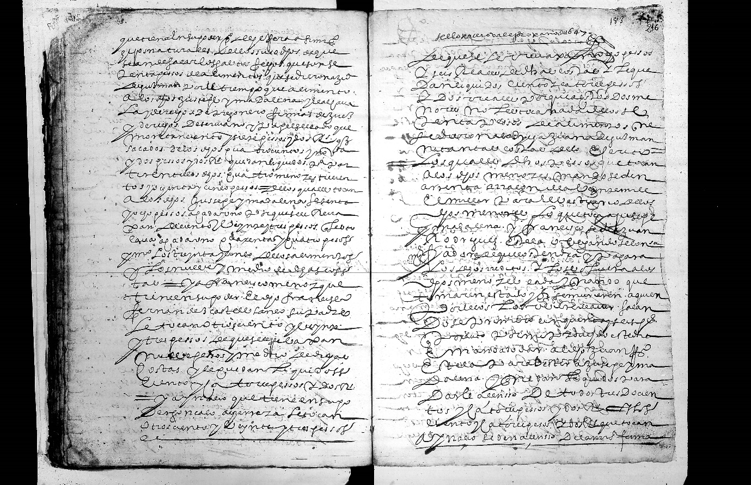

Prediction count :-307

Word count:- 290

Space count :- 17

Threshold Value:- 127

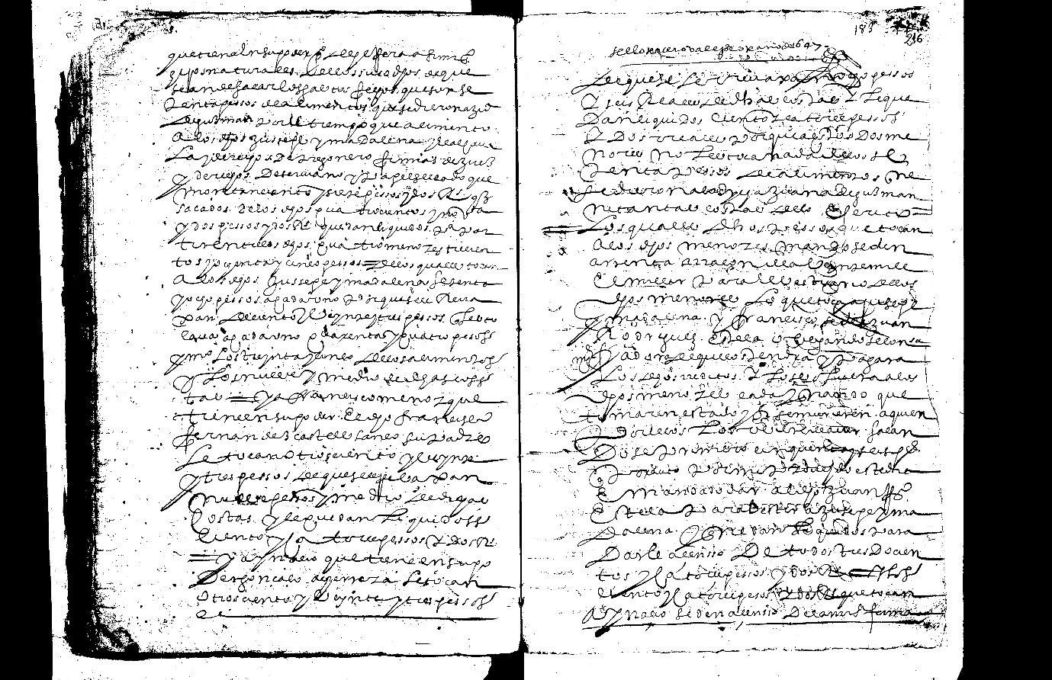

Prediction count:307

Word count: 290

Space count :17

Threshold value : 200

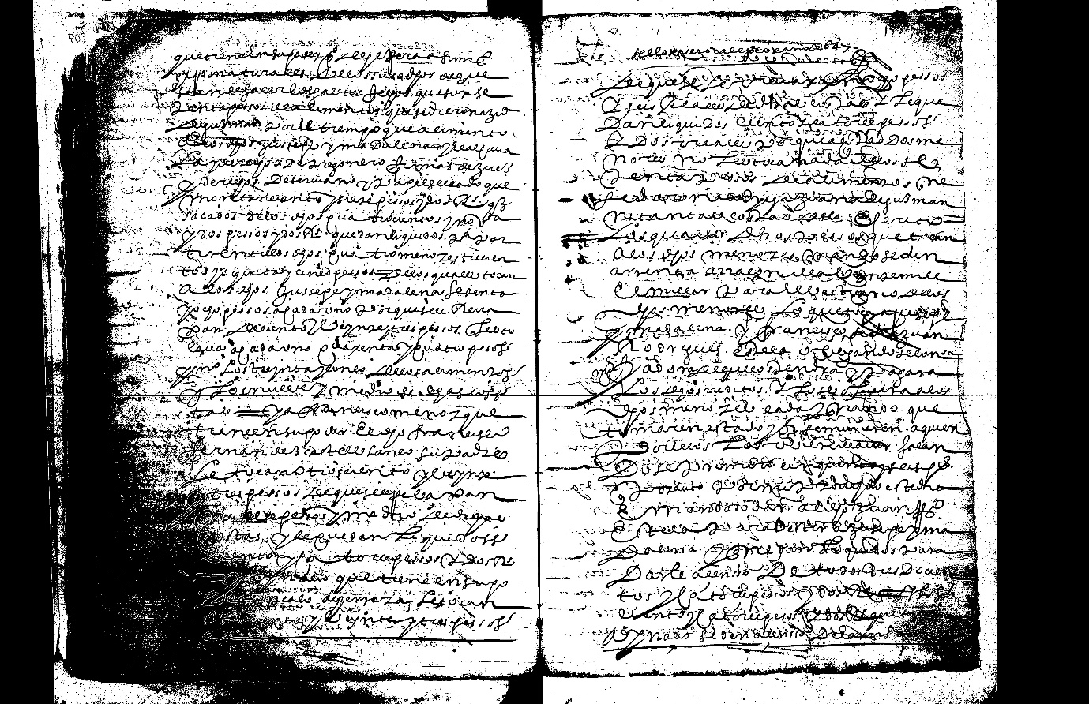

Prediction count : 246

Word count : 239

Space count : 7